OTC Drug Recommendation Chatbot

### Project Proposal

## 

## Supervisor

Sir Khawaja Mohiuddin

## Submitted by

Esa Anjum

1712145

Shayan-Ur-Rehman Siddiqui

1712172

**Faculty of Computing and Engineering Sciences**

Shaheed Zulfiqar Ali Bhutto Institute of Science and Technology, Karachi.

[14/10/2020]

# Introduction

Chatbots are becoming increasingly popular. Their main advantage is the level of interaction they provide to the user. In the field of medicine, AI powered chatbots can help identify a disease by checking symptoms and recommending Over-The-Counter medicine providing complete virtual doctor-patient interaction.

# Objective

"*To develop a Chatbot based medicine recommendation system that minimizes the need to go to the doctor for Over-The-Counter Drugs, assisting patients and pharmacists* ".

# Problem Description

What is the use: Chatbot can provide a seamless interaction for the end-user, it will be a hassle-free way of finding best suitable OTC medicines.

Why Chatbots are better than other basic systems and search engines: It eliminates any confusion that the users might have regarding their disease, it will provide precise information and only that a layman should know.

How Chatbots can be implemented: By using the power of NLP and decision tree algorithms in web application.[1]

# Methodology

A web application will be developed that has a chatbot that uses decision tree algorithm[1] to ask user a series of questions after he/she has initiated a conversation about his/her problem. The Chatbot will narrow down the problem to become certain of the user’s health issue, known allergies etc. and then recommend the best suitable medicines. The chatbot will look for meaningful data in conversations using Natural Language Processing and then provide the output in the form of suitable Over-the-Counter drugs along with their usage/dosage guide.

# Project Scope

In this project, User will input any queries related to disease, the system will process it and then recommend the best OTC medicine name along with some of its details like drug name and interactions. It is to be noted that this will only be used for mild to moderate symptoms, anything severe or chronic will not be dealt with. Here, we are expecting user to know English language and very basic knowledge about interacting with websites.

# Feasibility Study

There might be a few challenges along the way like time and expertise but our team has the ability to cope with any challenge this project might present:

* + 1. **Risks Involved**: Bad training of Chatbot which can result in inaccurate recommendations because time required to develop the AI part can take a lot of time.
    2. **Resource Requirement**: Fast reliable PC and internet connection.

# Solution Application Areas

This project targets the audience that don’t want to go to the doctor due to different reasons such as a minor illness/problem that doesn’t even need a doctor’s prescription. Using our app, they won’t be needing to visit hospitals, clinics thus saving time and money. People located in remote areas can easily find local drugs for their problems. It makes easier to buy drugs which won’t exacerbate your allergies, underlying problems as you will input all your allergies upfront which will result in showing only those medicines which meet your needs. Many people whenever they have any small health related issue they make online searches which may or may not provide accurate result and the medicines which will appear in search engines will not be Pakistani or may not be available locally[4].

This project is meant for users in Pakistan. We will be creating OTC drug database on drugs available in Pakistani markets our data source will be Pharmapedia Pakistan. The disease and drugs datasets will be mainly created using Pharmapedia Pakistan database and online reliable sources.

# Tools/Technology

Web Application;

Front-End: React.js

Back-End: Python Flask Framework

Libraries and Packages: Regular Expressions(NLTK), Wordnet, AI libraries.

DataSet/Database: “Pharmapedia Pakistan Database”[2], “KnowyourOTCs”[3] website, certified doctors and other online trusted sources which comply with FDA guidelines .

# Expertise of the Team Members

Both of the team members have basic knowledge about the project’s main features. For example; to make web apps, multiple courses have been taken and have been successfully completed. For training the bot, we are currently enrolled in an Artificial Intelligence course and also starting to learn Natural Language Processing. This project is also very much of interest of both the team members and that is why we are being really optimistic and enthusiastic to complete this great project

# Milestones

FYP-I

WEEK 1: Finalization of Idea and selecting a Supervisor.

WEEK 2: Research work will be performed.

WEEK 3,4: Gathering Information about Diseases and their OTC Drugs.

WEEK 5: Documentation will be done about the Chatbot.

WEEK 6,7,8: Making Decision Tree to recommend drugs using symptoms.

WEEK 9,10,11,12,13: NLP and training of the Bot.

WEEK 14: Designing basic UI.

WEEK 15,16: Final Documentation.

FYP-II

WEEK 1: Meeting with the Advisor and discussing about the scope.

WEEK 2: Research work will be performed for extension of the project

WEEK 3: Project proposal would be revised.

WEEK 4: Documentation will be done about the new extension and other software’s (If Included).

WEEK 5,6: Designing and building of Web App Front-End.

WEEK 7,8,9: Designing and building of Web App Back-End.

WEEK 10,11,12,13: Addition of discussed Features.

WEEK 14,15,16: Final Documentation.

# 11. Project Schedule

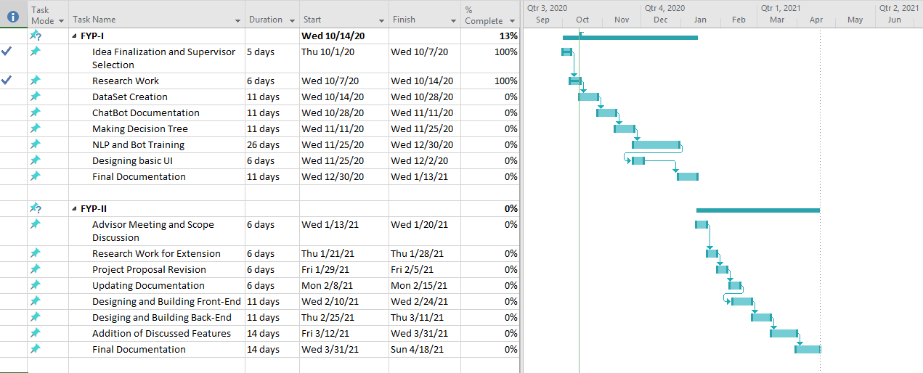

# 12. Work Breakdown Structure

FYP-I

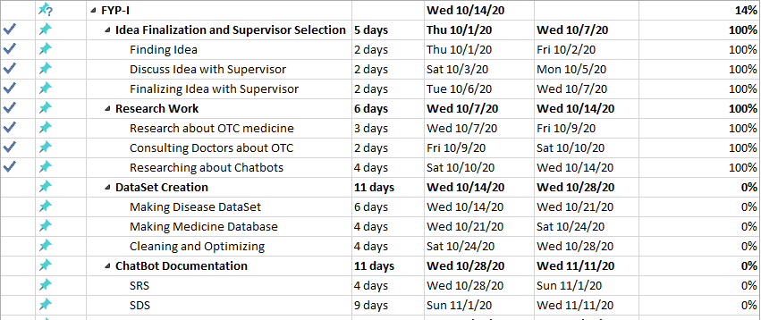

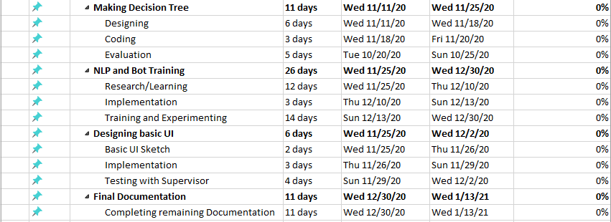

FYP-II

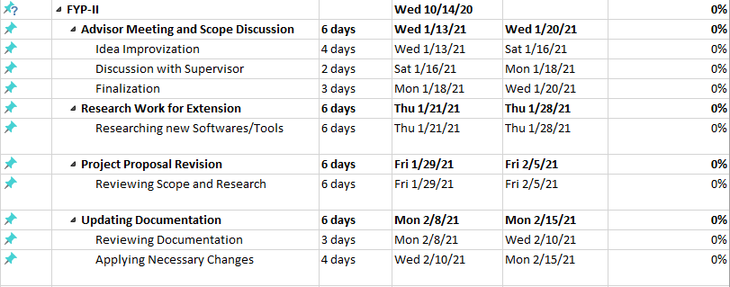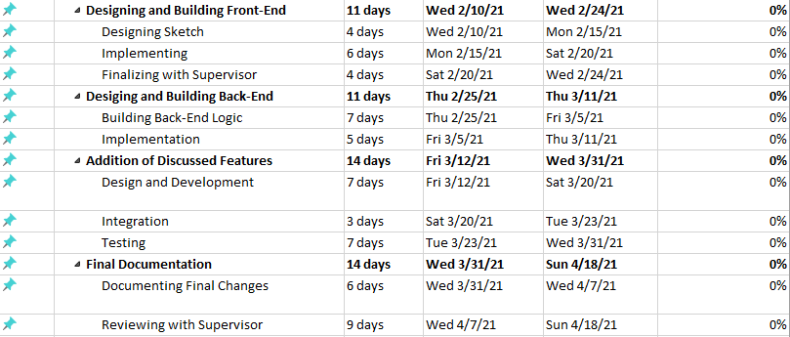

# 13. References

1. “Designing an over the counter consumer decision-making tool for older adults”. DOI: <https://doi.org/10.1016/j.jbi.2015.07.006>. https://www.sciencedirect.com/science/article/pii/S153204641500146X/
2. “Pharmapedia Pakistan”. <https://www.pharmapedia.pk/>.
3. “KnowyourOTCs”. CHPA Educational Foundation. <https://www.knowyourotcs.org/conditions-and-treatments/>.
4. “Scraping WebMD and Creating an OTC Drug Finder with Python”. Author: Jason Chen. <https://nycdatascience.com/blog/student-works/web-scraping-otc-drug-finder/>.